# Go: Fibonacci Sequence Rate Limiter

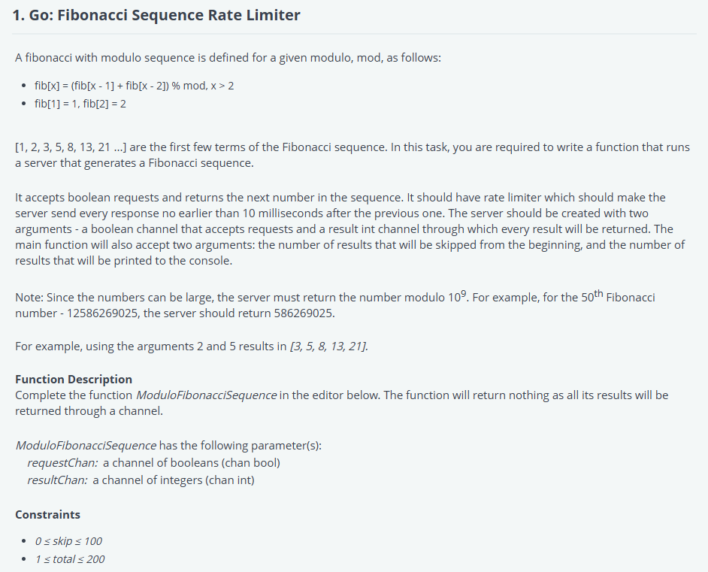

Go: Multiplier Batch Generation

